Cecil Andrews College

Year 11 Physics 2023

Waves Test

Student name: _____________ Result:_________/ 38

**Note:**

1. Calculations must show **clear working** with **formulae** and final answers stated to **three significant figures.**
2. Marks will be allocated for clear and logical setting out.
3. State your assumptions if working on open-ended type questions.
4. Underline your answers.
5. Half a mark may be taken off for incorrect number of significant figures and incorrect units in the final answer.

1. The following waveforms are produced when different musical instruments are played in front of a microphone. Each instrument is played in the same place each time. The oscilloscope controls remain unchanged. There is no external interference.

a) Identify which instrument is producing the loudest sounds and give a reason for your choice. (1)

b) How can you tell that all instruments are producing a note of the same pitch?

(1)

c) Why do all the notes have a different sound? (1)

2. Name the property of sound waves associated with each of the following:

a) An opera singer breaking a glass by singing. (1)

b) Hearing around corners. (1)

3. A speaker from a signal generator is attached to one end of a plastic tube that contains sawdust. Before the signal generator is switched on, the sawdust is distributed evenly over the length of the tube. When the signal generator is switched on, the frequency is adjusted and resonance is heard. The sawdust gathered into three piles as shown in the diagram below.

a) On the diagram above, draw the standing wave pattern in the tube at this frequency (1)

b) If the tube is 1.80 m long, what is the frequency of the signal generator? (2)

c) What is the fundamental frequency of this tube? (2)

4. A water wave, shown in the diagram below, is travelling to the right. It has a speed of $10.0 ms^{-1}$

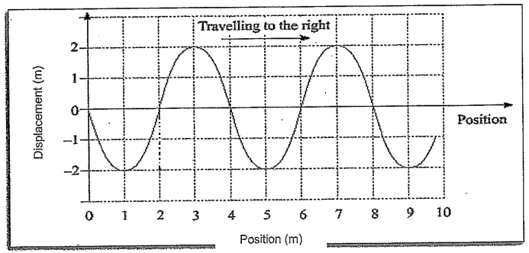

a) What is the amplitude of the wave? __________________ (1)

b) What is the wavelength of the wave? ___________________ (1)

c) Calculate the frequency of the wave. (2)

d) Calculate the period of the wave. (1)

e) Using an arrow on the diagram above, clearly show the direction of movement of the water’s surface at the 2 m position. (1)

5. A sound wave passes through a thick brick wall as shown below.

a) Complete the diagram showing the path of the sound through the brick and out the other side. Show the wave fronts. (4)

b) State what happens to the frequency, velocity and wavelength of the sound wave above by using the words **increases**, **decreases** or **remains the same** as the sound wave passes from **air** into the **brick**. (3)

Frequency ____________________________________

Velocity _________________________________________

Wavelength ____________________________________

6. A stationary car is observed at a set of traffic lights with its engine running. On the front of the car, the radio antenna is observed to be vibrating as shown in the diagram:

a) If the radio antenna is 1.25 m long, calculate the wavelength of the standing wave. (2)

b) The car’s engine idles at 500 rpm. Assuming that the radio antenna experiences 500 vibrations per minute, calculate the speed of the wave in the antenna. (2)

c) Explain how you could adjust the antenna to stop the tip (end) from vibrating?

(2)

7. A **closed pipe** is 50.0 cm long and is made to vibrate at its **first overtone**.

a) Draw a representation of the first overtone below (1)

b) Calculate the frequency of the wave. (2)

8. Define resonance and state one example. (3)

Definition:

Example:

9. a) Describe the relationship between sound intensity and distance. (1)

b) If your ear experiences Wm-2 of sound when you are 1.00 m from a sound source, what will be the theoretical new sound intensity experienced by your ear when you are standing 8.00 m from the same sound source? (2)

End of Test